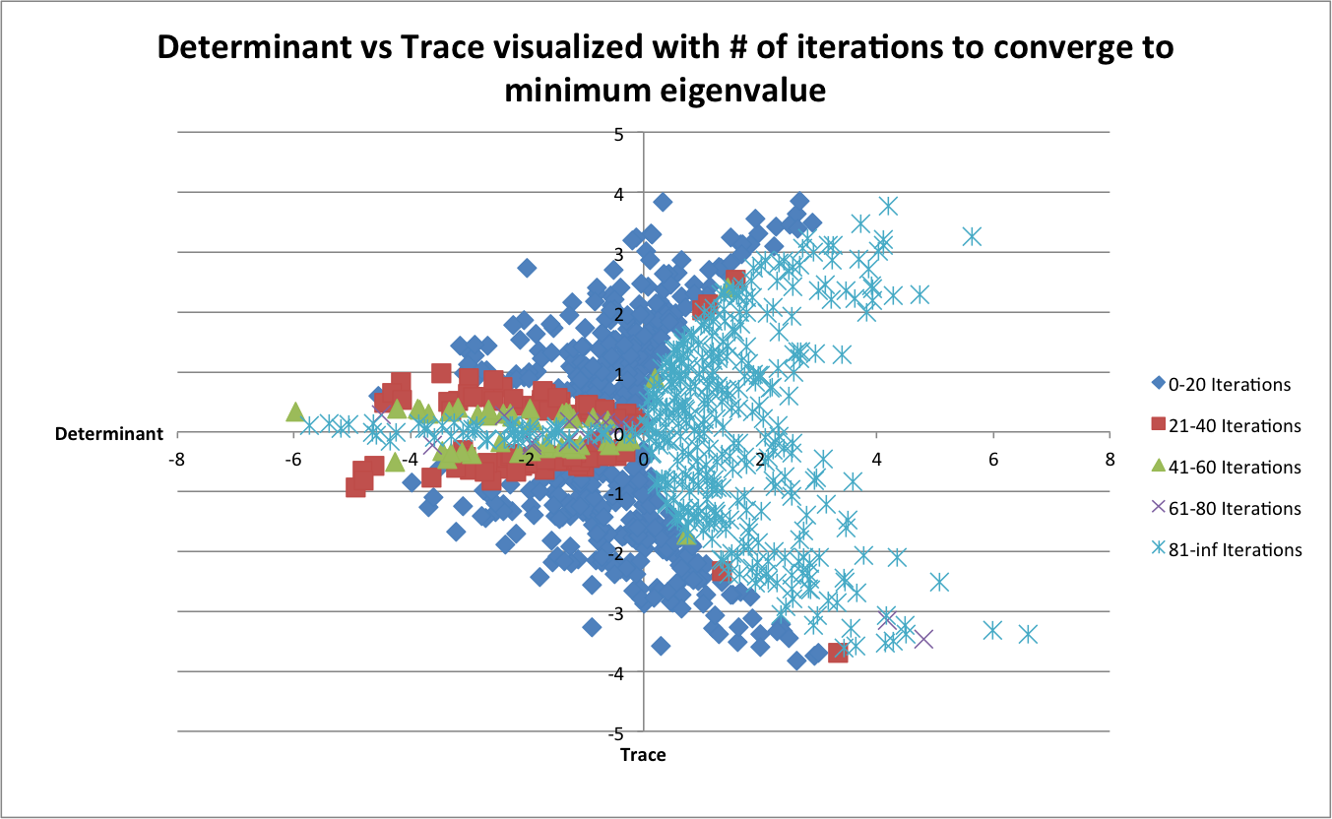

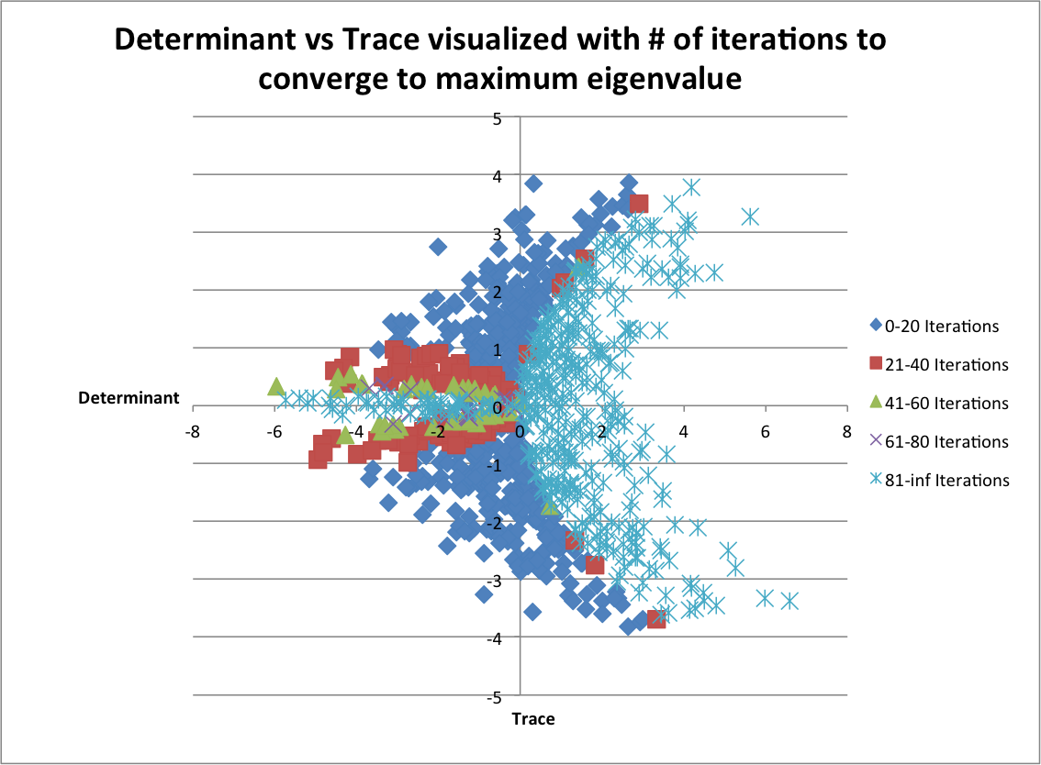

The two scatterplots look generally the same for calculating minimum eigenvalues and maximum eigenvalues. If the determinant is close to 0, and the trace is not 0, there is a very good chance that the power method will converge quickly. Interestingly, if the determinant is negative, there is a much better chance for convergence than when the determinant is positive. On the negative side of the determinant axis, the convergence patterns seem to follow the curves of an x=-y2 graph. The positive x axis is a much more bowl shaped graph, and seems to have a fine threshold between converging fast and not converging at all. This threshold seems to follow a graph like x = Ay2, where A is a smaller value, possibly ¼.